**Department of Computer Science**

Project Proposal Summer 24-25

|  |  |  |  |  |  |
| --- | --- | --- | --- | --- | --- |
| Course Title | WEB TECHNOLOGIES | Section | F | #Group | 9 |

**Group Member**

|  |  |  |
| --- | --- | --- |
| Student ID | Name | Signature |
| 22-49842-3 | MD NAIMURE RAHAMAN EMON | Emon |
| 22-49311-3 | MD. MOSADDEK MUTTAKEY | Mosaddek |

**Project Title:**

Library Management System

**Short Description:**

|  |
| --- |
| **Type of user: 1. Student, 2. Librarian**  **Common Features (Available to All Users)**   * **Authentication**    1. Login to the system   2. Logout from the system   3. User registration * **Account Management**    1. Change or reset password   2. Manage profile information (view, edit, delete) * **Dashboard**    1. Home dashboard   2. Access a personalized dashboard after login  **Specific Features by User Type** * **Features of Student**    1. Search for books by title/author/category   2. Borrow and return books   3. Cancel a borrow request   4. View fines   5. View borrowing history   6. Get notifications * **Features of Librarian**    1. Add new book   2. Edit book details (title, author, availability)   3. Delete a book from the catalog   4. View all borrowed books list   5. Approve/decline borrow requests   6. Post announcements (notice board) |

**Use Case Diagram:**

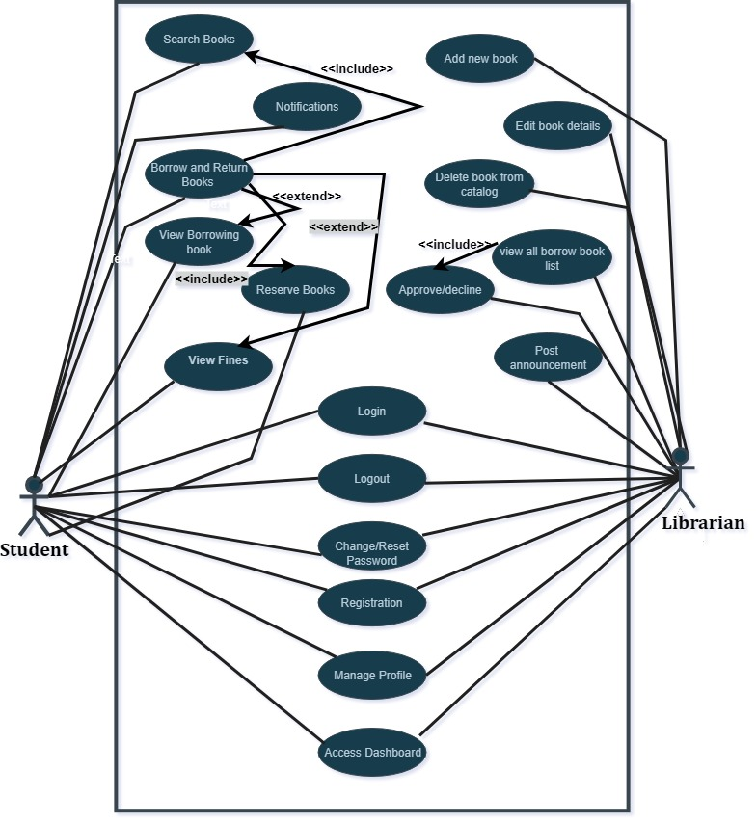

**Class Diagram:**

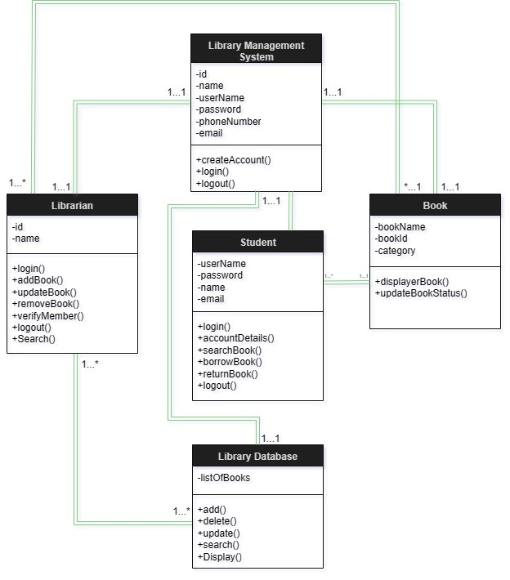

**Activity Diagram:**

